18 December 2012

Keys Communications Profile on Anisa- iAfrica.com R 20 000

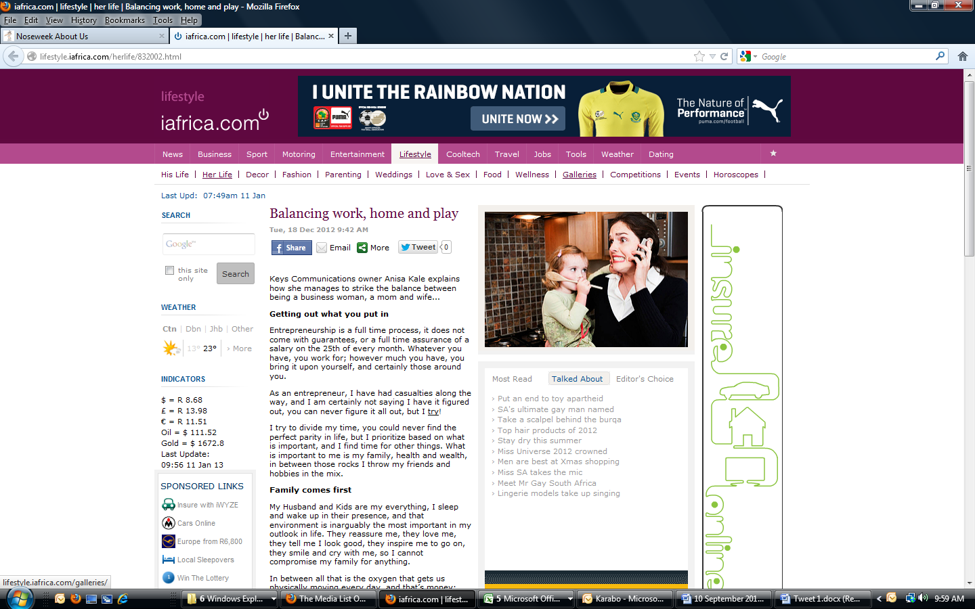

http://lifestyle.iafrica.com/herlife/features/832002.html